Grade 4
Parking Test

Description: | Students will:  Draw a car and a simple parking lot.  Use the drop shadow for all objects in the project.  Construct new commands from two objects’ script tiles.  Make a script to control simultaneous motion on the x and y axis. Construct new commands from two objects’ script tiles.  Experiment with script tiles for x/y increase and/or decrease.  Experiment with left/right and up/down options.  Make reset scripts to position objects at specific locations.  Type or draw a “You Passed the Parking Test” message.  Create a script that displays the Passed message appropriately.  Give the project a title.  Experiment with text color options.  Experiment with font and emphasis options  Write directions and include them in a flap.
Project View | 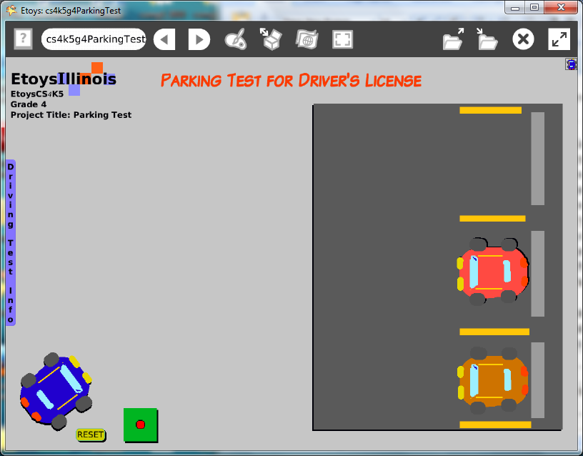
Subject: | Mathematics
Etoys Quick Guides | Click the question mark in Etoys to open the set of interactive tutorials for basic tools and techniques.
Vocabulary: | Forward, turn, heading, left/right, up/down, x and y locations, font, emphasis
Lesson 1:  Paint Tools; Brushes  Paint Tools: Straight Line Tools  Script Tiles: Scale Factor | Draw the background setting.  Use a paint palette to paint a background and keep it. Open its white menu and select: resist being picked up, be locked to keep it from covering the moving objects by accident.  Draw the car.  Include headlights and taillights.  Change the scale of the car to fit the parking places in the project.  Copy the car to fill all but one of the parking places. Change the color of the cars so each is distinctive.  Publish the project: nameCarPark e.g. KateCarPark
Lesson 2:  Script Tiles: Forward and Turn  Supplies: Joystick | Make a script to move the car; use forward and turn.  Add a joystick control.  Change the color and size of the joystick and its ellipse to control the range of motion.  Keep the project
Lesson 3:  Menus: Button to Fire a Script  Menus: Drop Shadow | Make a reset script and button to fire it. The reset script locates the starting location of the car. It is more a more interesting project if a random number is added to the x and y locations.  Use the white halo menu: drop shadow for as many objects as possible. Experiment with shadow color and offset options.  Keep the project
Lesson 4  Supplies : Text  Supplies : Add a New Flap | Type or draw a title, change the font, color and emphasis.  Add a flap. Change the color using the white halo menu.  Change the flap’s tab wording using its white halo menu.  Add text to the flap with directions and rules.  Keep the project.  Give students time to try neighbors’ projects and to make further modifications to their project.
Standards: | Common Core Standards  Mathematics: 4.OA.3.5; 4.NF.5.7  Bloom’s Taxonomy/Cognitive Domain:  Knowledge: selects  Application: demonstrates, produces, uses, constructs, changes  Analysis: analyzes, compares, experiments  Synthesis: categorizes, modifies, plans  Evaluation: compares, reviews  NETS  1. a, b, c  2. a  3. b  4. a
Resources: | Etoys Help Quick Guides: always available in Etoys. Open Etoys and click the question mark to open a set of interactive tutorials of basic tools and techniques.  www.etoysillinois.org projects, lesson plans, software download  www.mste.Illinois.org more math, science, and technology resources  www.corestandards.org Common Core Standards  www.squeakland.org software and Etoys projects  www.nctm.org Standards and Focal Points for each grade level
kh
January 2011

Mathematical Practices
1. Make sense of problems and persevere in solving them.
2. Reason abstractly and quantitatively.
3. Construct viable arguments and critique the reasoning of others.
4. Model with mathematics.
5. Use appropriate tools strategically.
6. Attend to precision.
7. Look for and make use of structure.
8. Look for and express regularity in repeated reasoning.

